**Convolutional Neural Network Tutorial: From Basic to Advanced**

<https://missinglink.ai/guides/convolutional-neural-networks/convolutional-neural-network-tutorial-basic-advanced/>

## WHAT IS A CONVOLUTIONAL NEURAL NETWORK?

A Convolutional Neural Network (CNN) is the foundation of most computer vision technologies. Unlike traditional [multilayer perceptron](https://missinglink.ai/guides/neural-network-concepts/perceptrons-and-multi-layer-perceptrons-the-artificial-neuron-at-the-core-of-deep-learning/) architectures, it uses two operations called ‘convolution’ and pooling’ to reduce an image into its essential features, and uses those features to understand and classify the image.

The basic building blocks of CNN are:

* **Convolution layer**━a “filter”, sometimes called a “kernel”, is passed over the image, viewing a few pixels at a time (for example, 3X3 or 5X5). The convolution operation is a dot product of the original pixel values with weights defined in the filter. The results are summed up into one number that represents all the pixels the filter observed.
* **Activation layer**━the convolution layer generates a matrix that is much smaller in size than the original image. This matrix is run through an activation layer, which introduces non-linearity to allow the network to train itself via [backpropagation](https://missinglink.ai/guides/neural-network-concepts/backpropagation-neural-networks-process-examples-code-minus-math/). The activation function is typically ReLu.
* **Pooling layer**━“pooling” is the process of further downsampling and reducing the size of the matrix. A filter is passed over the results of the previous layer and selects one number out of each group of values (typically the maximum, this is called max pooling). This allows the network to train much faster, focusing on the most important information in each feature of the image.
* **Fully connected layer**━a traditional multilayer perceptron structure. Its input is a one-dimensional vector representing the output of the previous layers. Its output is a list of probabilities for different possible labels attached to the image (e.g. dog, cat, bird). The label that receives the highest probability is the classification decision.

There may be multiple activation and pooling layers, depending on the CNN architecture.

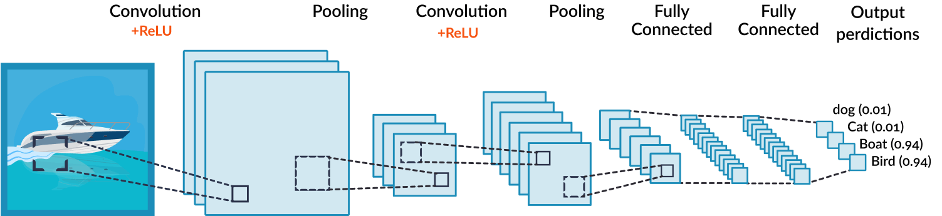

## CNN FOR COMPUTER VISION: COMMON APPLICATIONS

People are doing cool things with CNN. Here are some common applications of computer vision powered by Convolutional Neural Networks:

* **Agriculture**━farmers use hyperspectral or multispectral sensors to take pictures of crops, and analyze the images with computer vision to determine their health, or the viability of seeds to be sown.
* **Self-driving cars**━CNNs are used for object detection and classification, performed in real time against live video footage from car cameras. Today’s self-driving cars are able to identify other vehicles, people and obstacles and navigate around them with surprising accuracy.
* **Surveillance**━modern security systems with computer vision capabilities can identify crime, violence or theft in video footage in real time and alert security personnel. Again this leverages CNN-based object detection and classification in video frames.
* **Healthcare**━[computer vision in healthcare](https://missinglink.ai/guides/computer-vision/deep-residual-learning-for-computer-vision-in-healthcare/) helps diagnose diseases like pneumonia, diabetes and breast cancer. In many cases CNN-based analysis and diagnosis of medical images can be as accurate or even more accurate than a human technician or physician.